Czech MTB STRABAG Cup 2019
MTB: XCO Cross-Country C1
3rd race 2019: Pec pod Sněžkou, Czech Republic
11th - 12th May 2019
Technical Guide

Main Organizer: Z&S Apache Team, EXPRES CZ – TUFO TEAM KOLÍN
www.exprescz-tufo.cz

Organizer: Czech National Cup license holder - Czech MTB Ltd.
www.poharmtb.cz

Location: Pec pod Sněžkou, piste “Javor”
50°41'18.129"N, 15°43'40.360"E, http://goo.gl/maps/PpWPm

Race date: Sunday 12th May 2019

Event class: UCI C1 race for XCO race for cat. Man and Woman Elite and Man and Woman Juniors

Race director: Mgr. Jan Slavíček, tel.: +420 777 722 710
e-mail: slavicek@cyclingagency.cz

Anti Doping: AntiDoping controls will be carried out according to the regulations of UCI

Course director: Mgr. Jan Slavíček, slavicek@cyclingagency.cz

Course: length of 3000m with 133m elevation per one race lap. Race course mainly on forest tracks, meadow tracks, singletrails and forest trails with enough place for overtaking.
Training on race course during race days will be available only according the time schedule – course is available with basic marking already one week prior to the race.

Race office: BULL BAR (piste “Javor”), Pec pod Sněžkou 366, 542 21 Pec pod Sněžkou
Accommodation:
Hotel**** Horizont
www.hotelhorizont.cz

Parking locations teams, riders, public areas & Expo areas:
On a designated area inside the Event Centre. Please register your team space by e-mail: team@cyclingagency.cz

Directions: There will be MTB signs on the main directions and over the city to navigate you directly to the race point.

Hinterland: Bicycle cleaning – directly in the race venue

Registration: On-line registration of all categories available only on www.poharmtb.cz, direct registration on spot will NOT available Additional fee may be applied.
Race numbers will be provided to teams and riders onsite.
Pick-up will be organized in the race office in the event center
on 11. and 12. 5. 2019 accosrding to the time schedule. Last chance to pick up the numbers and transmitters is two hours before the start of category at the race office.

Location and information of nearest hospital
Medical service is provided by www.horskasluzba.cz
Nearest hospital www.nemtru.cz

Time-keeping information: photo-finish, use of light beams and/or transponders
Fully provided by the SportSoft timing company that holds all relevant timing licences (www.sportsoft.eu). Electronic timing system will be used with transponders attached to front fork of riders’ bicycles. Light beams will not be used. Photo-finish will be used as a result documentation. Intermediate times will be decided after the each courses have been finalized. There will be Speed trap applied – one lap regulation or 80% regulation. This will be mentioned on race meeting at Saturday 11th May 2019 at 7pm.

Course MAP:
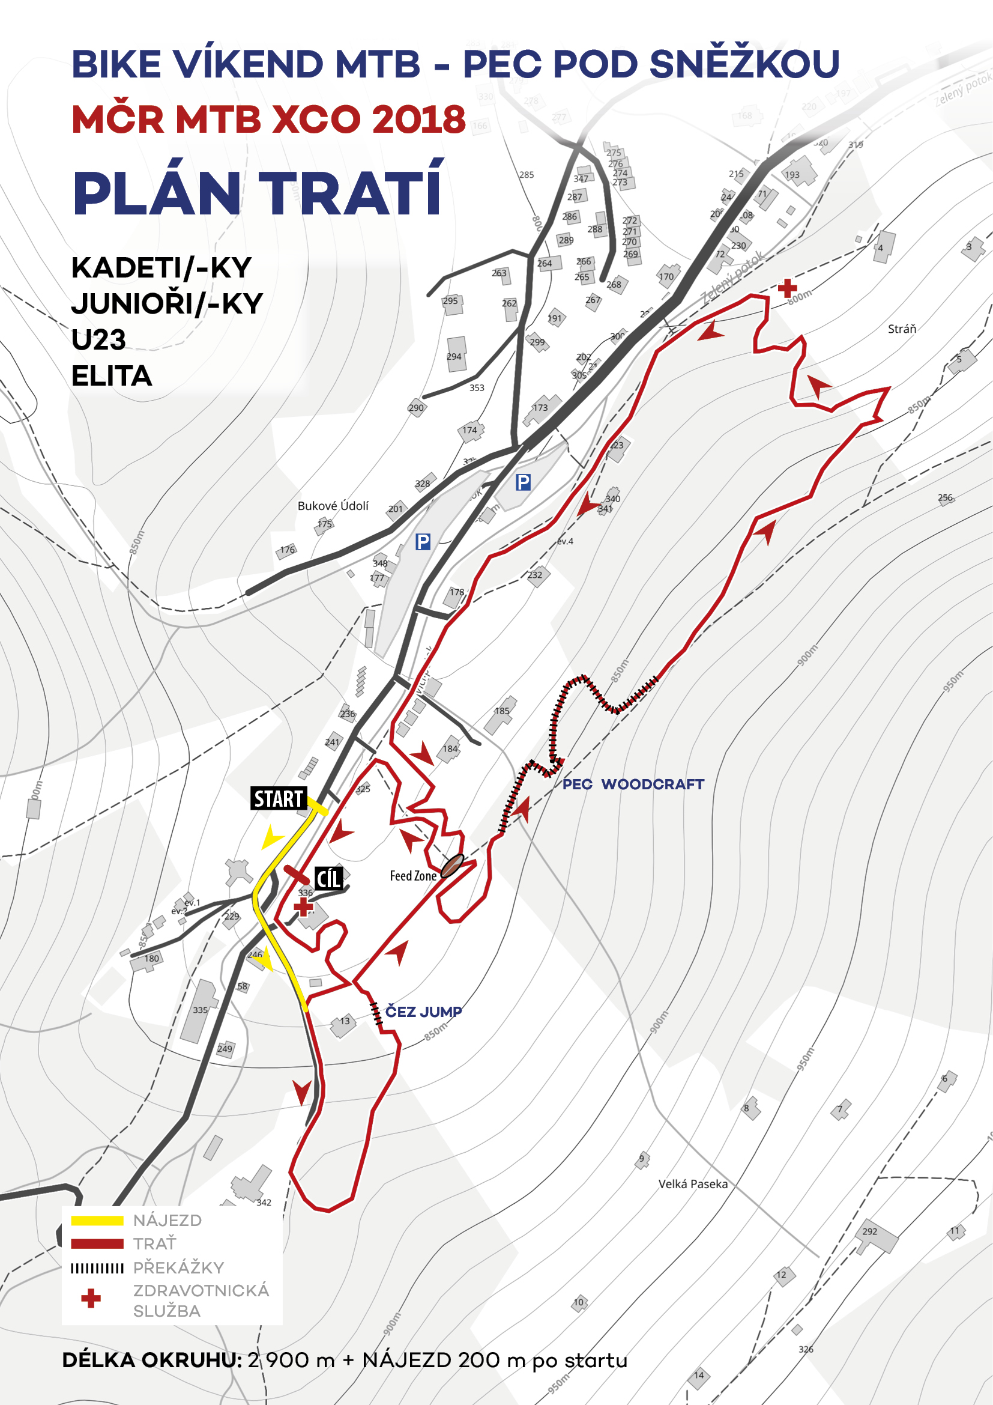

Maps Notes: START – for all categories
CÍL = finis area

Location of award ceremonies, Anti-doping tests, race office, press conference room, race meeting room, etc.
All of the located at race venue directly at race area and main race point – BULL BAR and race venue

Class of the event, categories of riders:
Race is registered as C1 race by UCI regulation for Men Elite & Women Elite and Juniors categories

Detailed race program:
Friday:
5pm – 7pm Race office to pay the start fee, pickup the race numbers and transmitors
Saturday:
8am – 6pm Race office to pay the start fee, pickup the race numbers and transmitors
19pm manager meeting
Sunday:
8am – 4pm race office for numbers pick-up – limit is two hours before the category start; office open for registration, race numbers pick-up, result service, press service and information service

race starts: Saturday 9:00 pupil man and woman
13:10 expert and masters man
Sunday 9:30 cadets man
10:30 juniors man
12:30 cadets woman, junior woman, woman elite/U23
14:30 man elite/U23
16:30 winner’s ceremony

Composition of the commissaries’ panel:
President of the Commissaires Panel:
???
delegation of 6 XCO Commissaires will be covered by Czech national union

Points scale, prize list: According to the UCI rules applicable for the C1 event

NOTE: All riders must wear a cycling helmet by riding on the race course, also during the training. Only riders with valid license issued with UCI code can start by the race. All riders carry full risk on them self during the race and training. The race organizer doesn’t cover any damage competitors incurred or caused by.

